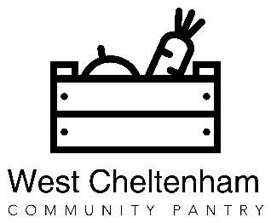
West Cheltenham Pantry Manager
Person Specification

 | Essential | Desirable
Education and Qualifications

NVQ Level 3 or equivalent. | x
Experience in a related post and able to demonstrate competence to undertake the duties required. | x
Ability to demonstrate continuous improvement and self-development. | x
Training in behavioural change technique such as motivational interviewing or equivalent experience. |  | x
Experience & Knowledge

Experience of working directly in an adult health and social care, public health, or community development context. |  | x
Experience of working within or with the voluntary and community sector in a paid or voluntary role. |  | x
Experience of monitoring, evaluation and data collection. |  | x
Experience of building relationships and working in partnership with a variety of organisations and individuals. | x
Experience in co-ordinating and developing volunteers |  | x
Skills

Knowledge of health promotion and self-care principles. |  | x
Knowledge of the local area served by the service. | x
Experience of community development approaches to health and wellbeing issues. |  | x
Ability to express oneself effectively verbally and in writing at a range of levels and with a variety of partners and stakeholders. | x
Knowledge and ability to utilise Microsoft IT systems, e-mail and social media. | x
Understanding of how to improve service quality for the benefit of users. | x
Knowledge of voluntary and community services in the Cheltenham. | x
Basic cookery skills and knowledge of food preparation and storage | x
Driving license | x
Qualities and Abilities

Ability to maintain effective working relationships and a positive attitude towards collaborative work with peers, colleagues and other professionals. | x
Ability to motivate and influence others. | x
Proven ability to interact with people in a way that inspires trust and confidence. | x

